Test Case: tc001_SPX_Dev5_Validar_Filtro_Campo_MenuName_Administrador_Roles_Menu
Step 1 - Enter username and password and click to button Enter : Credentials Entered
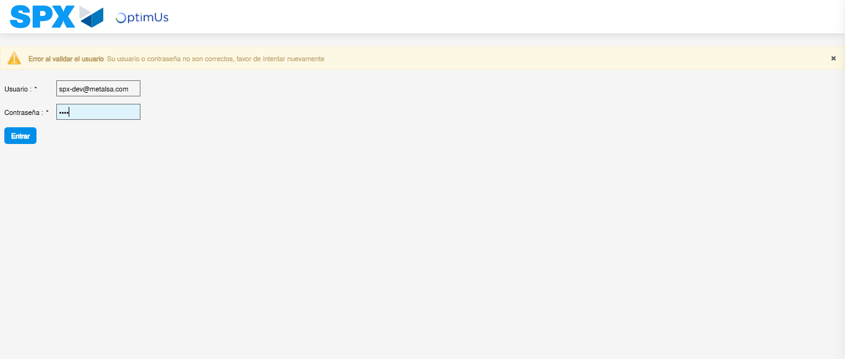Image file-name: QC_Testing-tc001_SPX_Dev5_Validar_Filtro_Campo_MenuName_Administrador_Roles_Menu-dic. 03 2025, 09 19 59 a. m.

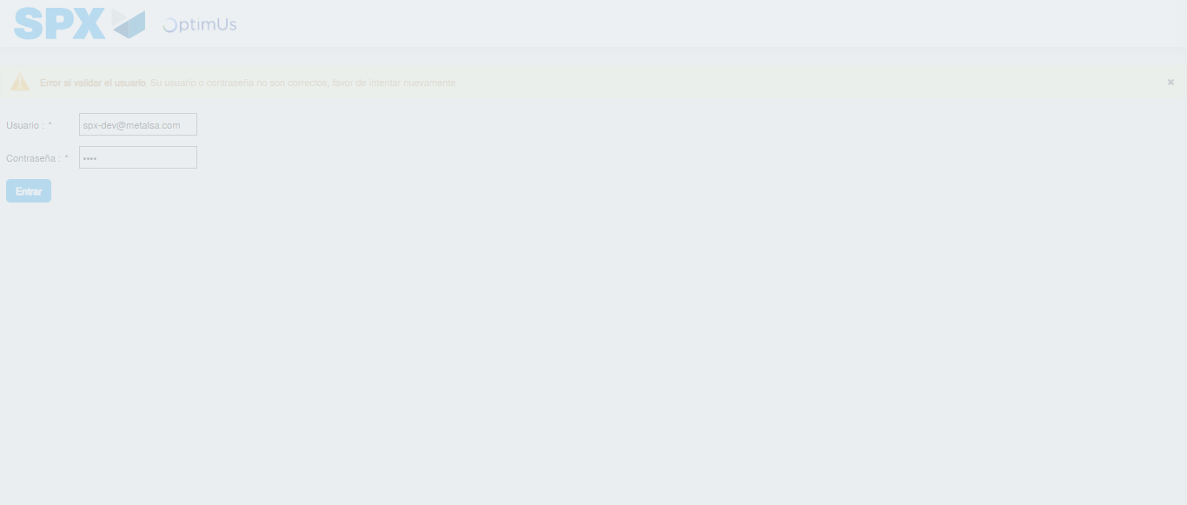Image file-name: QC_Testing-tc001_SPX_Dev5_Validar_Filtro_Campo_MenuName_Administrador_Roles_Menu-dic. 03 2025, 09 20 00 a. m.

Step 2 - Select to UEN and Access to Administrador Roles Menu: UEN Correctly selected and Correct access
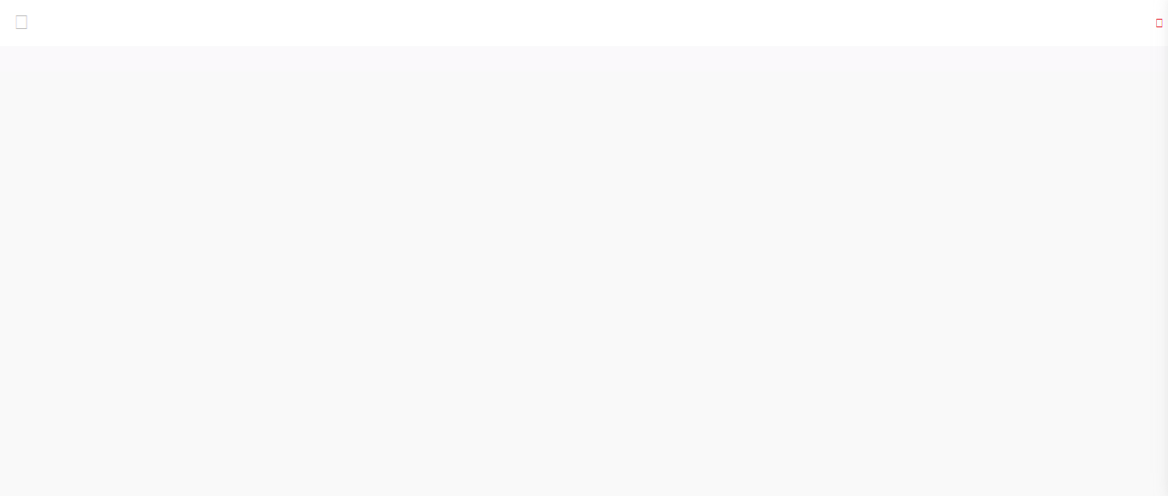Image file-name: QC_Testing-tc001_SPX_Dev5_Validar_Filtro_Campo_MenuName_Administrador_Roles_Menu-dic. 03 2025, 09 20 12 a. m.

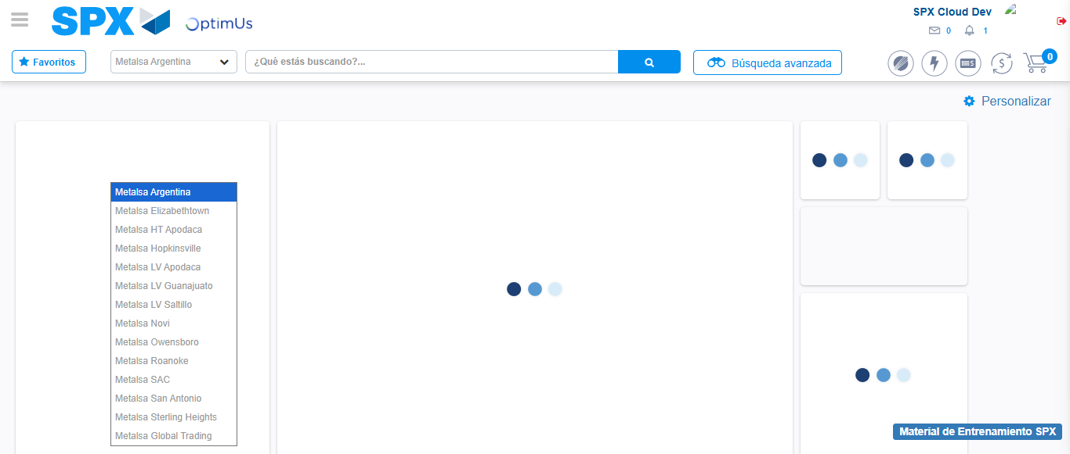Image file-name: QC_Testing-tc001_SPX_Dev5_Validar_Filtro_Campo_MenuName_Administrador_Roles_Menu-dic. 03 2025, 09 20 14 a. m.

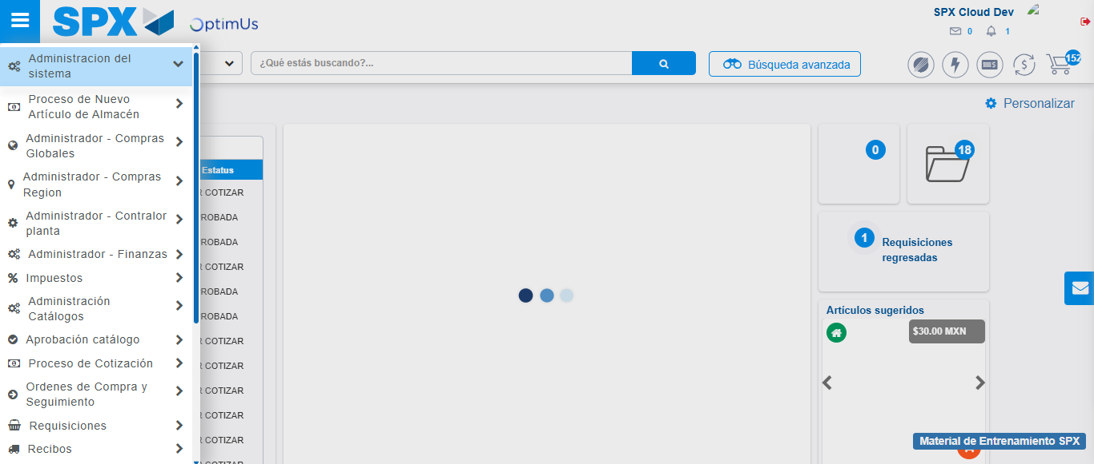Image file-name: QC_Testing-tc001_SPX_Dev5_Validar_Filtro_Campo_MenuName_Administrador_Roles_Menu-dic. 03 2025, 09 20 15 a. m.

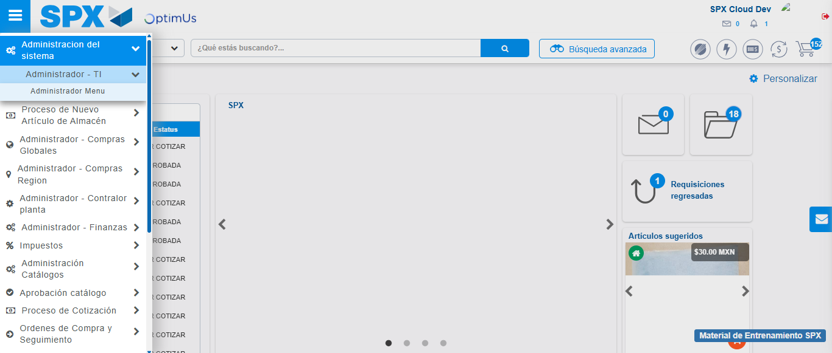Image file-name: QC_Testing-tc001_SPX_Dev5_Validar_Filtro_Campo_MenuName_Administrador_Roles_Menu-dic. 03 2025, 09 20 16 a. m.

Image file-name: QC_Testing-tc001_SPX_Dev5_Validar_Filtro_Campo_MenuName_Administrador_Roles_Menu-dic. 03 2025, 09 20 21 a. m.

Step 3 - Click to Buttons View Menu and Search Filter with Menu Name: Correct Search
Image file-name: QC_Testing-tc001_SPX_Dev5_Validar_Filtro_Campo_MenuName_Administrador_Roles_Menu-dic. 03 2025, 09 20 21 a. m.

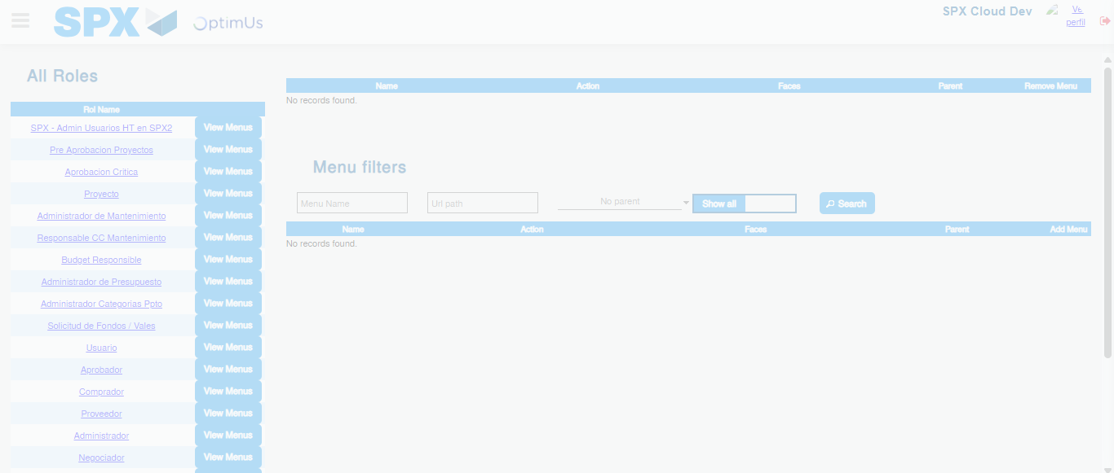Image file-name: QC_Testing-tc001_SPX_Dev5_Validar_Filtro_Campo_MenuName_Administrador_Roles_Menu-dic. 03 2025, 09 20 22 a. m.

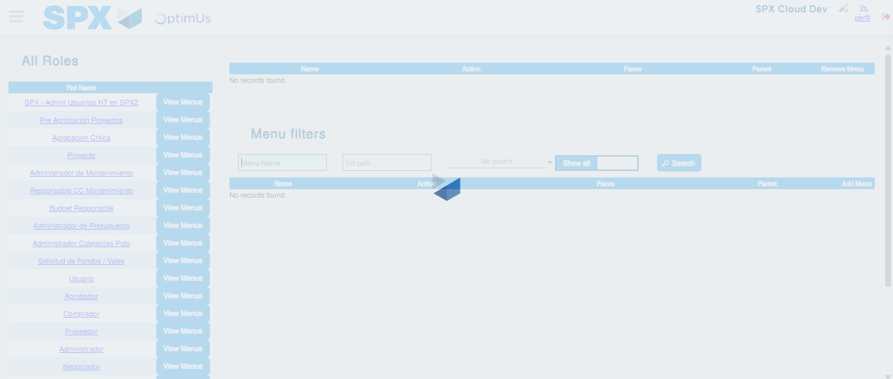Image file-name: QC_Testing-tc001_SPX_Dev5_Validar_Filtro_Campo_MenuName_Administrador_Roles_Menu-dic. 03 2025, 09 20 23 a. m.

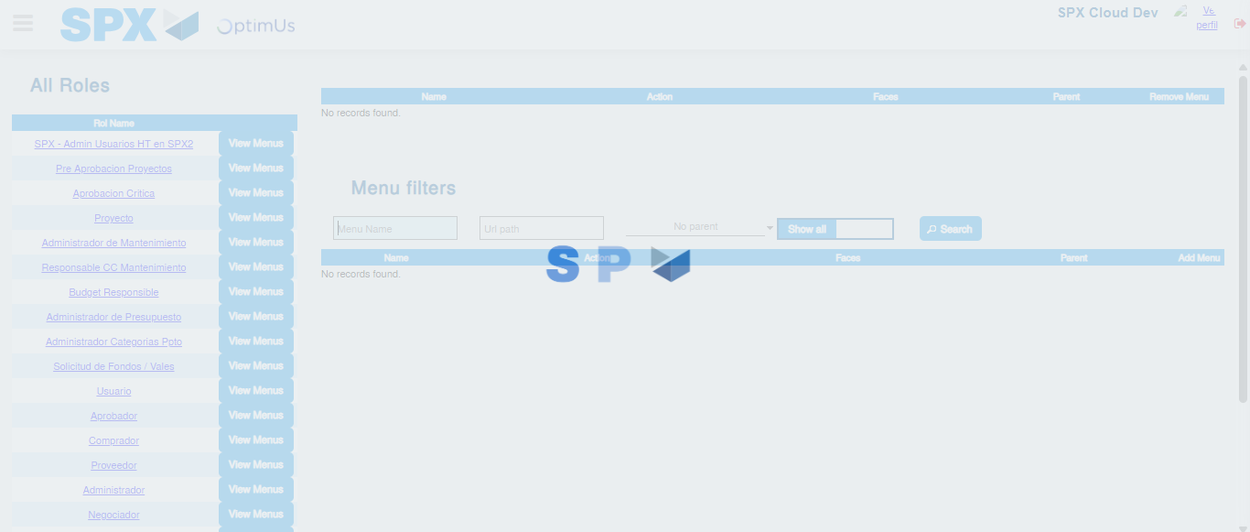Image file-name: QC_Testing-tc001_SPX_Dev5_Validar_Filtro_Campo_MenuName_Administrador_Roles_Menu-dic. 03 2025, 09 20 24 a. m.

